**A Study on Data Communication Generations**

**TO -**

<A . Murali Mohan Kumar > ,Associate Professor, Head of the Department MCA, Mother Theresa Institute of Computer Application, Palamaner.

FROM -

<**A . Usha**> , Student , MCA , MTICA , Palamaner.

**Abstract:**

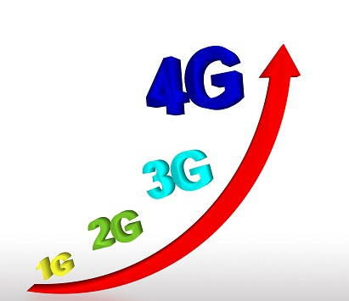Data Communication, the exchange of data between devices, is a fundamental aspect of modern technology, evolving through generations like 1G, 2G, 3G, 4G and 5G, each offering advancements in speed, capacity and capabilities. Data communication means is the process of transferring data between two or more devices over a transmission medium. The effectiveness of data communication System depends on Delivery, Accuracy, and Timeliness.

**Keywords:**

Sender, Receiver, Message, Transmission Medium, Protocol

Introduction:

Data Communication specifically refers to the process of using computing and communication technologies to transfer data from a sender to a receiver. Each generation of networks brought a significant milestone in the development of mobile communication.

***First Generation (1G):***

First Generation mobile networks relied on analogue radio system, which meant that user could only make phone calls and not send or receive text messages. The 1G network was first introduced in japan in 1979 before rolled out in other countries, such as the USA, in 1980. Cell towers were

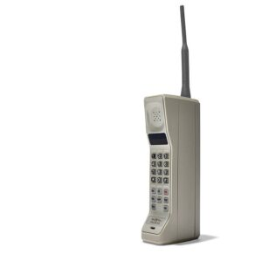

**1G Wireless System**

built around the country to make it work, meaning that signal coverage could be obtained from greater distance. However, the network was unreliable and had some security issues .For instance, cell coverage would often drop, it would experience interference by other radio signals, and it could easily be hacked due to a lack of encryption.

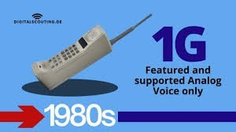

**Second Generation (2G):**

The 1G network was not perfect, but it remained until 1991, when it was replaced with 2G.The new mobile network ran on digital signal, not analogue, vastly improving

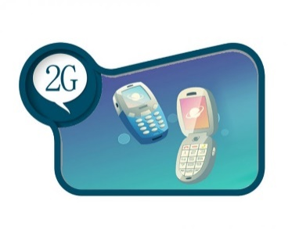its security and capacity. On 2G, user could send SMS and MMS message (although slowly and often without success), and when GPRS was introduced in 1997, users could receive and send email on the move.

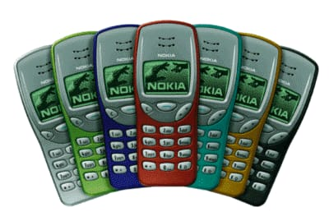

**Third Generation (3G):**

Third-generation mobile networks are still in use, but normally, when the superior 4G signal fail.3G revolutionized mobile connectivity and the capabilities of cell phones. Compared to 2G, 3G was much faster and could transmit greater amounts of data. This means that users could video call, share files, surf the internet, watch TV online, and play games on their mobiles for the first time.

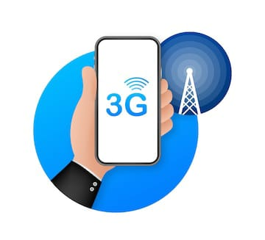Under 3G, cell phones were no longer just about calling and texting; they were the hub of social connectivity.

**Fourth Generation (4G):**

The introduction of 4G went one step further than revolutionary 3G.

It is five times faster than the 3G network and can theoretically proves speeds of up to 100Mbps. All mobile released from 2013 onwards should support this network, which can offer connectivity for tablets, laptops, and smartphones.

Under 4G, user can experience better latency(less buffering), higher voice quality, easy access to instance messaging services and social media, quality streaming, and faster downloads.

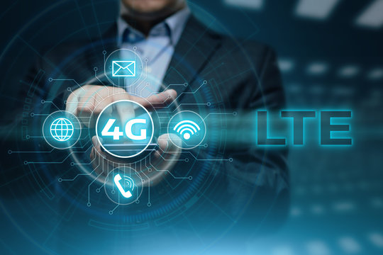

**Fifth Generation (5G):**

The network has arrived and has been largely welcomed by the mobile industry. The network has changed more than our mobile use and affects how we connect our device to the internet. The improved speed and the massive network capacity have developed new lo T trends, such as smart cities, healthcare, connected cars.

5G can theoretically have a download speed 20X faster than 4G and boasts a very low latency compared to its predecessor. This means the time delay for online gaming, video calls, and critical mission applications will be significantly lower.

With almost a decade of 5G development left, the technology’s full potential is yet to come. The 5G network will revolutionize how people live and work worldwide, so expect to see exciting changes in the coming years.

|  |
| --- |
| . |

**Upcoming Generation (6G, 7G):**

The tech world is already buzzing about 6G.

Expected to launch around 2030, 6G will take wireless communication to new heights, offering speeds up to 100 times faster than 5G.

It promises to usher in advanced application like high-fidelity holographic communication, AI-driven network, and ultra-precise location sensing. The leap from 6G to7G will mark significant advancement in technology, further connecting the world in ways we’re just beginning to imagine.

6G internet is a conceptual wireless network technology that will succeed 5G.6G technology will be its low energy consumption .It could reach to remote locations with no Internet Access via satellite, humans will have better communicate with robots. Robots and drones might perform dangerous jobs in place of humans.

Various new industry bodies have

each made proposals on the roadmap for 6G.

**CONCLUSION :**

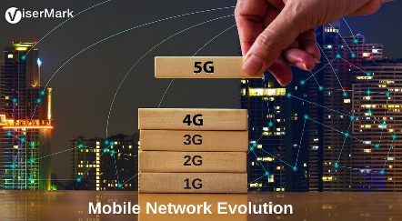

The timeline and history from 1G to 5G took just over 40 years since the introduction of wireless cellular technology. And a lot has changed since then.

* Cell phones have become smaller.
* Download speeds have become faster.
* Text messaging has come ([and almost gone](https://www.statista.com/chart/12109/sms-volume-in-the-united-states/)).
* Surfing the internet with phones became common.
* The steam of social media posting continues.
* And apparently, there’s an app for nearly everything now.

The timeline from 1G to 5G couldn’t have happened without creating and enhancing each generation of telecommunications leading to what it is today. Roughly every ten years since 1979, each newer generation has changed how we communicate, further improving our way of life.

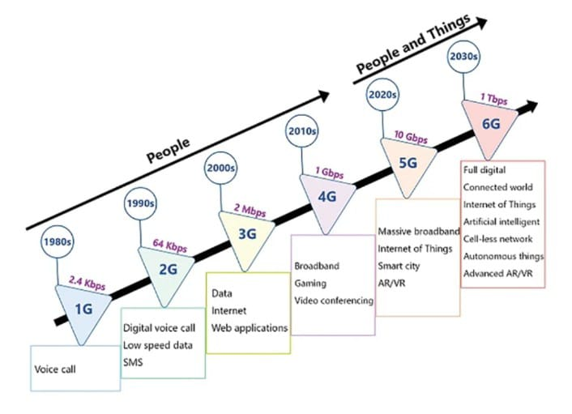

EVOLUTION OF CELLULAR NETWORKS